Game Design Document

Fill up the following document

1. Write the title of your project.

Farming and Selling

1. What is the goal of the game?

Plant Apples, Sell them and Get more money and with the money grow more apples. But collect the apple from the tree before they disappear or you will lose the game. If you sell 40 apples you win.

1. Write a brief story of your game.

You are a farmer and have a big land. You want to grow apples in your farm. So you go to the market and

buy a huge sack of seeds. Now you need to plant them and sell them to the market to buy more stuff in the

game.

1. Which are the playing characters of this game?

* Playing characters are the ones who respond to the user based on the input from the user.
* Cars, monkeys, dinos, wizards, etc., are the playing characters in the game.

|  |  |  |
| --- | --- | --- |
| Number | Character Name | What can this character do? |
| 1 | Farmer | You controle the character |
| 2 |  |  |
| 3 |  |  |
| 4 |  |  |
| 5 |  |  |
| 6 |  |  |
| 7 |  |  |
| 8 |  |  |

1. Which are the Non-Playing Characters of this game?

* Non-Playing characters are the ones that don't have an action or behavior when the user interacts with the game.
* Hurdles, stones, bananas, coins, etc., are non-playing characters in the game.

|  |  |  |
| --- | --- | --- |
| Number | Character Name | What can this character do? |
| 1 | Market | To sell the apples |
| 2 | Seeds | To plant the apple treees |
| 3 | Apples | To sell |
| 4 | Trees | To grow and collect apples from |
| 5 | Money | To buy more seeds |
| 6 | Shopkepper | To handle the market |
| 7 | Mud, Water, Sun, Trees | To plant and grow the trees |
| 8 | Basket | To collect the apples |

Draw your imagination of this game. What does this game look like?

* Draw the game either on your computer or on paper.
* Add images of the game scenes to show each of the playing and non-playing characters at least once.

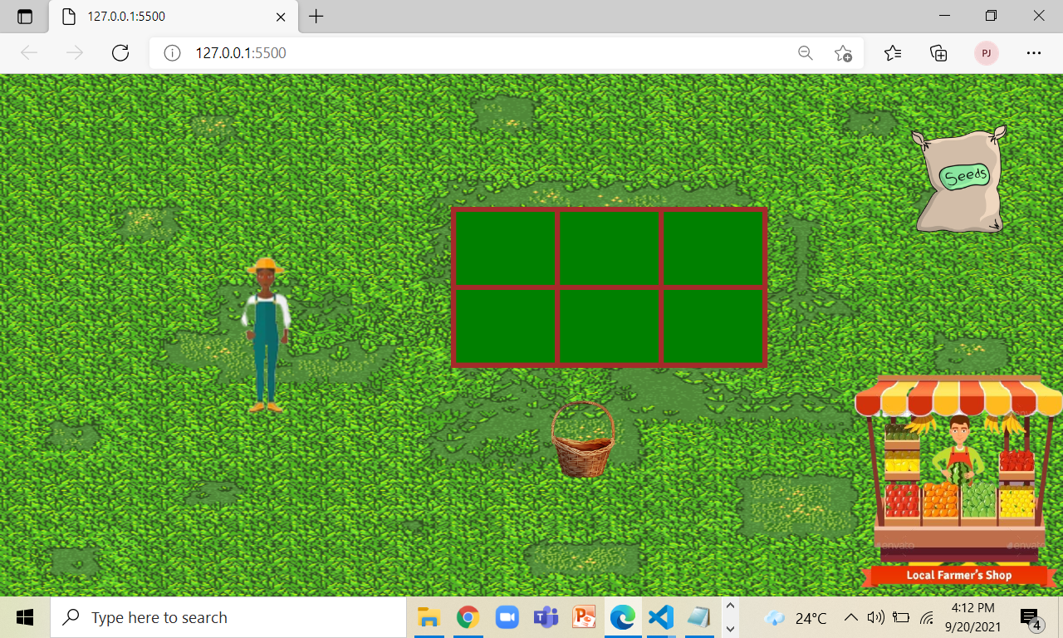

How do you plan to make your game engaging?

Sound effects and Its not too easy nor too hard to win the game.